EXPT NO: 7 | GENERATE SYNTHETIC IMAGES USING A GENERATIVE ADVERSARIAL NETWORK (GAN)
DATE: 05-10-2026

PRE-LAB QUESTIONS (PROVIDE BRIEF ANSWERS TO THE FOLLOWING QUESTIONS)

- What is a Generative Adversarial Network (GAN)?
A Generative Adversarial Network (GAN) is a deep learning model used to generate new synthetic data, such as images, that resemble real data. It consists of two neural networks called the Generator and Discriminator, which compete with each other during training.

- What are the roles of the Generator and Discriminator in a GAN?
The Generator creates synthetic images from random noise and tries to make them look realistic. The Discriminator examines both real and synthetic images and predicts whether they are real or fake. Both networks improve through continuous training.

- Why are GANs used for synthetic image generation?
GANs are used to generate realistic images and create additional training data for machine learning models. They are also useful in image enhancement, image editing, and data augmentation when the available dataset is limited.

- What is the difference between real images and synthetic images?
Real images are captured using cameras or other imaging devices from the real world. Synthetic images are artificially created using computer algorithms or generative models. GAN-generated images can look similar to real images even though they are computer-generated.

- Explain the concept of adversarial training in GANs.
Adversarial training is the process in which the Generator and Discriminator compete against each other. The Generator tries to create realistic images to fool the Discriminator, while the Discriminator tries to identify fake images correctly. Through repeated training, the Generator gradually learns to produce more realistic images.

AIM
To implement a Generative Adversarial Network (GAN) for generating synthetic images by training a Generator and Discriminator on an image dataset and evaluating the quality of the generated images.

SOFTWARE REQUIREMENTS
- Python
- TensorFlow / Keras
- Google Colab
- GitHub
- NumPy
- Matplotlib
- Pandas

OBJECTIVES
Students will be able to:
- Understand the architecture and working of Generative Adversarial Networks.
- Understand the roles of the Generator and Discriminator.
- Prepare and preprocess an image dataset for GAN training.
- Build a Generator network for synthetic image generation.
- Build a Discriminator network for distinguishing real and generated images.
- Train a GAN using adversarial learning.
- Generate synthetic images using the trained Generator.
- Visualize and analyze the quality of generated images.

PROCEDURE
PART A: DATASET PREPARATION AND IMAGE PREPROCESSING
Perform the following tasks:
- Load an image dataset such as the MNIST handwritten digit dataset.
- Explore the dataset and examine sample images.
- Check the number of images and image dimensions.
- Display sample images from the dataset.
- Normalize the pixel values to the range [-1, 1].
- Reshape the images into the required input format.
- Prepare the dataset for batch-wise training.
- Create a data pipeline using appropriate TensorFlow/Keras utilities.
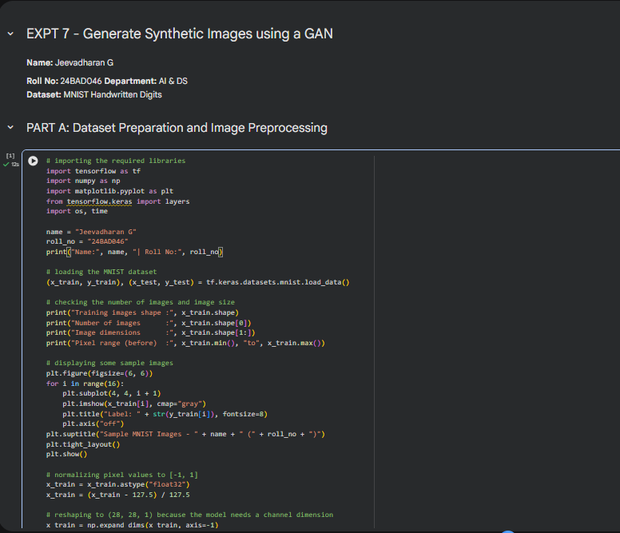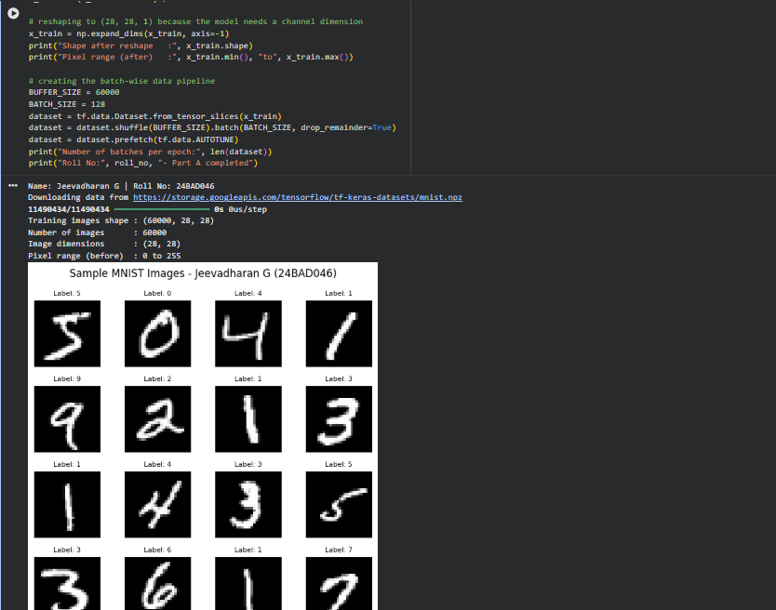
PART B: IMPLEMENTING THE GENERATOR
Perform the following tasks:
- Define a random noise vector as the input to the Generator.
- Create the Generator using appropriate neural network layers.
- Use Dense and convolutional/transposed convolutional layers to generate images.
- Apply appropriate activation functions.
- Generate an image from a random noise vector.
- Display the generated image before GAN training.
- Display the Generator model architecture and summary.
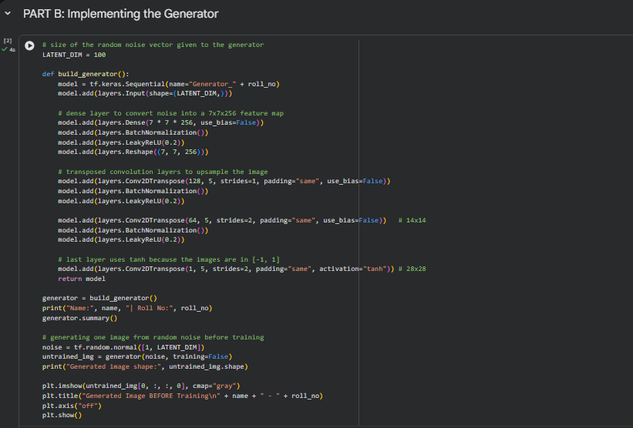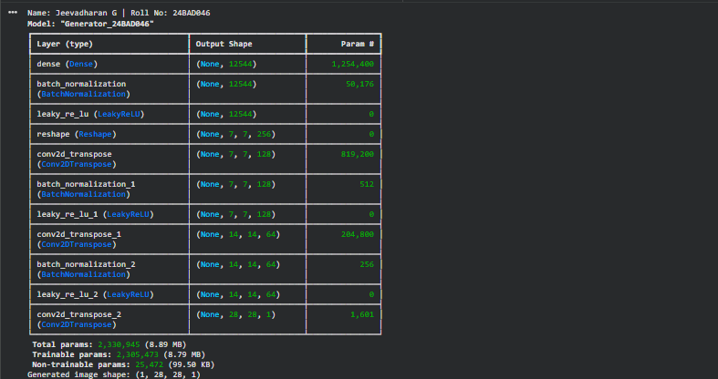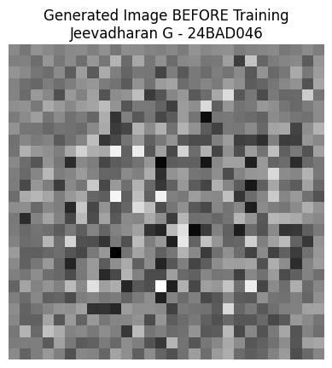
PART C: IMPLEMENTING THE DISCRIMINATOR AND GAN MODEL
Perform the following tasks:
- Create a Discriminator network to classify images as real or generated.
- Add convolutional layers to extract image features.
- Add appropriate activation functions.
- Add a final output layer for binary classification.
- Compile the Discriminator using:
  - Appropriate optimizer
  - Binary cross-entropy loss
- Combine the Generator and Discriminator to form the GAN.
- Display the Generator and Discriminator model summaries.
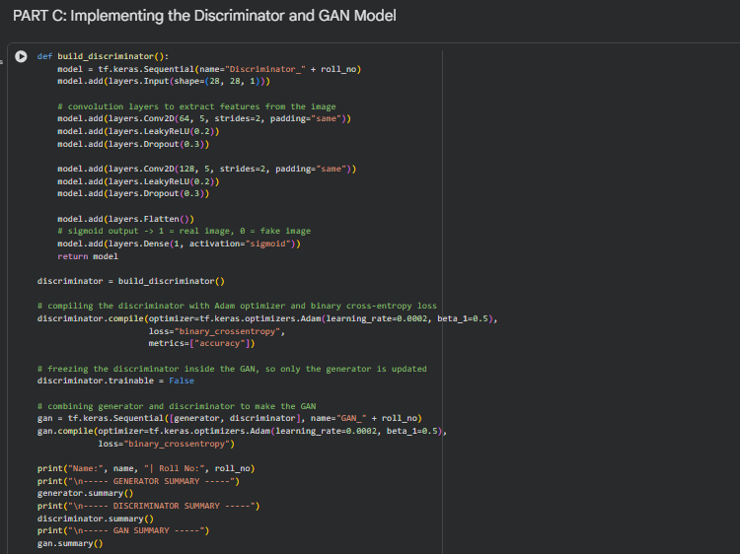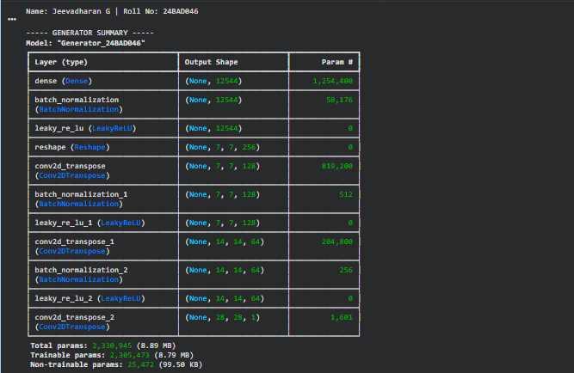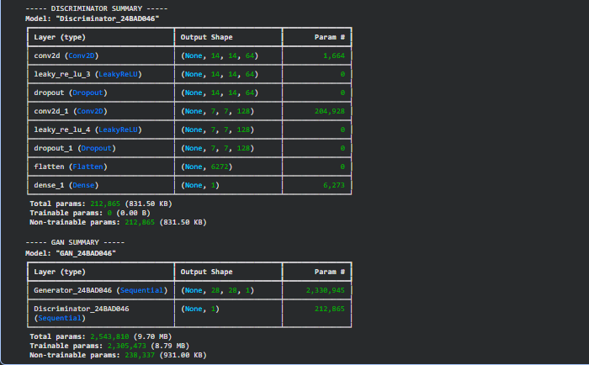
PART D: GAN TRAINING AND SYNTHETIC IMAGE GENERATION
Perform the following tasks:
- Initialize the Generator with random noise.
- Train the Discriminator using:
  - Real images from the dataset.
  - Synthetic images generated by the Generator.
- Train the Generator through the combined GAN model.
- Record:
  - Generator loss
  - Discriminator loss
- Repeat the training process for the specified number of epochs.
- Generate synthetic images at regular training intervals.
- Visualize generated images at different stages of training.
- Compare the generated images with real images.
- Analyze the quality and diversity of the generated images.
- Save the final generated images.
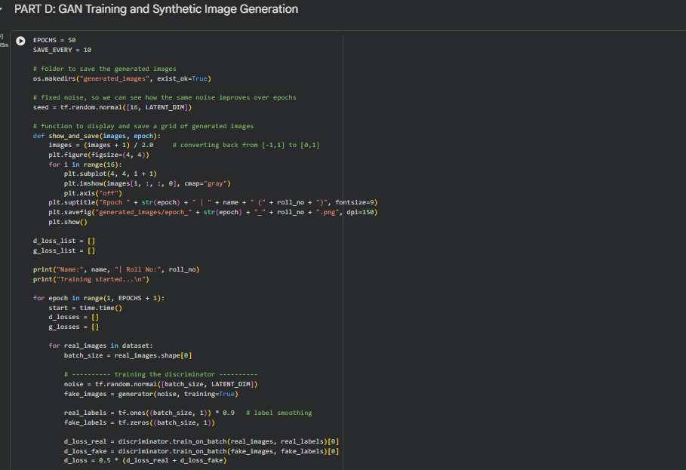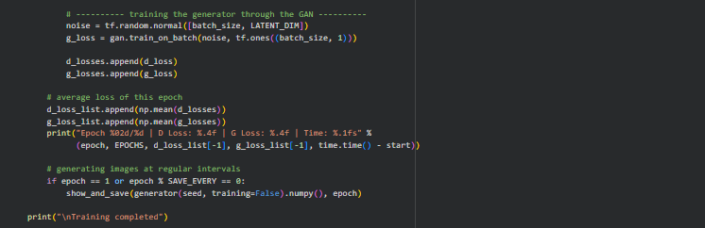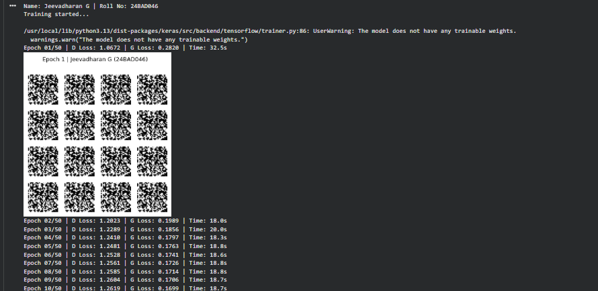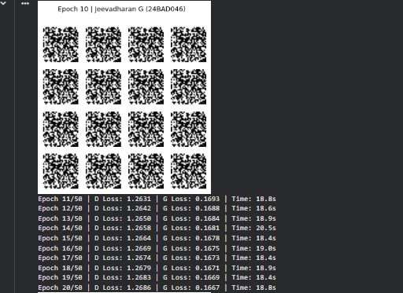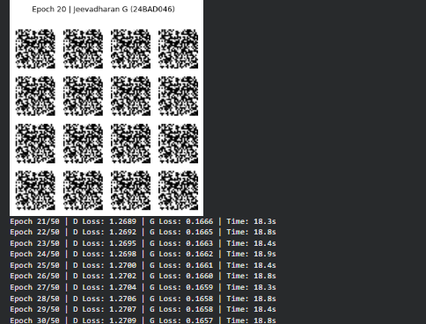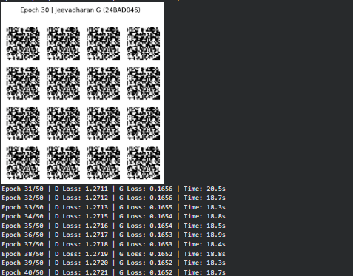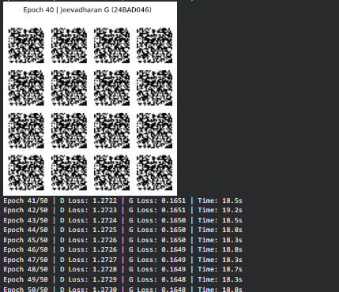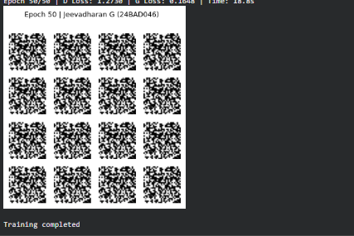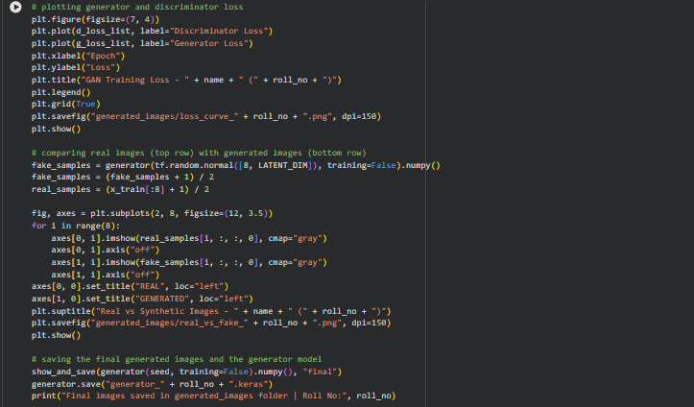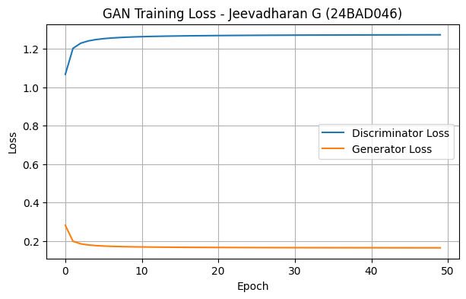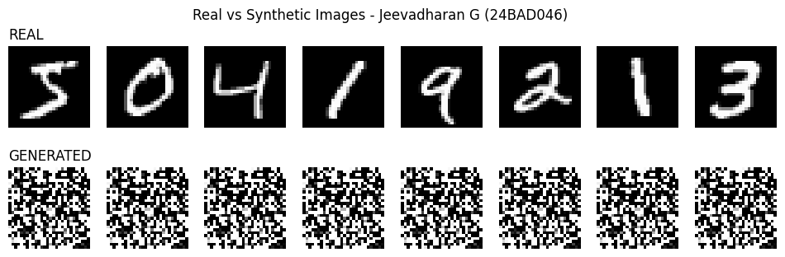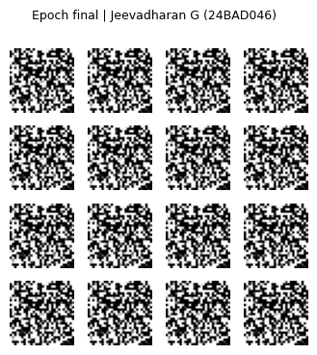

EXPECTED OUTCOME
Students will understand the architecture and working of Generative Adversarial Networks (GANs) and the interaction between the Generator and Discriminator during adversarial training. Students will learn to preprocess image data, build and train GAN models, and generate synthetic images. They will evaluate the generated images by visually comparing them with real images and analyzing the improvement in image quality during training.

POST-LAB QUESTIONS (PROVIDE BRIEF ANSWERS TO THE FOLLOWING QUESTIONS)

- What is the role of the Generator in a GAN?
The Generator takes a random noise vector as input and converts it into synthetic images. During training, it learns the patterns and features of the real dataset to generate increasingly realistic images that can fool the Discriminator.

- What is the role of the Discriminator in a GAN?
The Discriminator is responsible for distinguishing real images from synthetic images generated by the Generator. It learns to classify images as real or fake and provides feedback that helps the Generator improve its image-generation ability.

- Why is random noise used as input to the Generator?
Random noise is used as input to introduce variation in the generated images. Different noise vectors can produce different synthetic images, allowing the Generator to create diverse outputs rather than repeating the same image.

- What happens when the Discriminator becomes too strong during GAN training?
When the Discriminator becomes too strong, it can easily identify synthetic images as fake. This may provide insufficient learning signals to the Generator, making it difficult to improve the quality of generated images and causing training instability.

- What is meant by mode collapse in GANs?
Mode collapse is a problem in GAN training where the Generator produces only a small variety of images, even when different random noise inputs are given. As a result, the generated images lack diversity and fail to represent the different patterns in the original dataset.

- How does the Generator improve the quality of generated images during training?
The Generator improves by learning from the feedback provided by the Discriminator. During repeated training iterations, it adjusts its network parameters to produce images that are more similar to real images. This process gradually improves the quality and realism of the generated images.

- Mention one real-world application of GANs.
One real-world application of GANs is image enhancement. GANs can improve the resolution and visual quality of low-resolution images. They are also used in image restoration, artificial image creation, medical imaging, and realistic face generation.

- What is the difference between GAN training and conventional neural network training?
Conventional neural networks generally learn by minimizing a loss function using training data and target outputs. GAN training involves two competing networks: the Generator creates synthetic images, and the Discriminator evaluates whether they are real or fake. Their competition helps the Generator learn to produce realistic synthetic images.

SUGGESTIONS FOR DATASETS
- MNIST Handwritten Digits – https://www.tensorflow.org/datasets/catalog/mnist
- Fashion-MNIST – https://www.tensorflow.org/datasets/catalog/fashion_mnist
- CIFAR-10 – https://www.tensorflow.org/datasets/catalog/cifar10
- CelebA – https://www.tensorflow.org/datasets/catalog/celeb_a
- Oxford-IIIT Pet Dataset – https://www.tensorflow.org/datasets/catalog/oxford_iiit_pet

ASSESSMENT
Description | Max Marks | Marks Awarded
Pre Lab Exercise | 5
In Lab Exercise | 10
Post Lab Exercise | 5
Viva | 10
Total | 30
Faculty Signature

